CRM APPLICATION THAT HELPS TO BOOK A VISA SLOT

VISA SLOT BOOKING

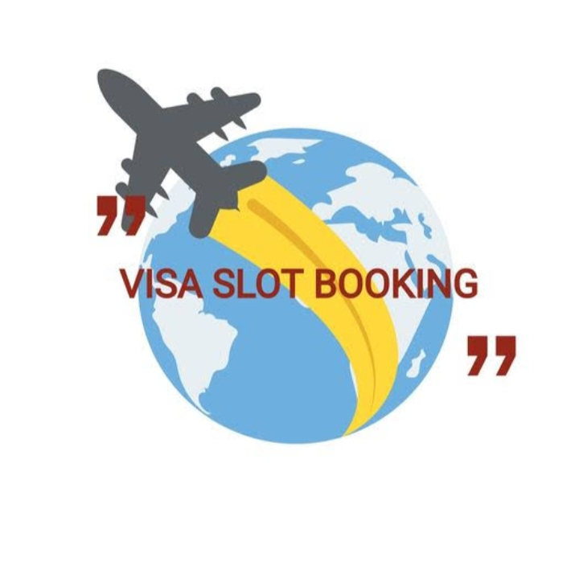

PROJECT NAME:

CRM APPLICATION THAT HELPS TO BOOK A VISA SLOT



TEAM ID: NM2023TMID00794

Team Leader: 1. MONIKA.R

Team Members: 2. MADHUMITHA. C

3. MANISHA.M

4. MEENA.S

TABLE OF CONTENTS

1. INTRODUCTION
2. THE BEST APPLICATION FOR BOOK A VISA SLOT
3. IDEAS TO IMPROVE VISA BOOKING
4. FLOECHART
5. CONCLUSION

INTRODUCTION:

In the Visa slot booking system will speed up the software is mainly used for applying for the visa also, it will store the information for the future transaction.

THE BEST APPLICATION FOR BOOK A VISA SLOT: